Task No: 7  Date:17/10/25 | Implementing Producer and Consumer problem in kafca.  Tools: Apache kafca | CO3
AIM:
To install and configure the apache kafca in windows operating system, and to perform the Producer and Consumer problem.
PROCEDURE:
- Install Java Development Kit (JDK) version 8 or higher.
- Install ZooKeeper: Kafka relies on ZooKeeper for distributed coordination. Kafka comes with an inbuilt Zookeeper
- Visit the Apache Kafka website (https://kafka.apache.org/downloads) and download the latest version of Kafka for Windows.
- Extract the contents of the Apache Kafka ZIP file to a required directory
- Configure Environment Variables and path in System and User settings.
- Start zookeeper by execute the zookeeper-server-start.bat script and pass the zookeeper configuration file path
cd C:\bigdata\kafka2.5
start cmd /k bin\windows\zookeeper-server-start.bat config\zookeeper.properties
- Start Kafka by executing the kafka-server-start.bat script and pass broker configuration file path. cd C:\bigdata\kafka2.5
start cmd /k bin\windows\kafka-server-start.bat config\server.properties
- Open a new command prompt, and create new Kafka topic.
bin\windows\kafka-topics.bat --create --bootstrap-server localhost:9092 --replication-factor 1 -- partitions 1 --topic test
Created topic test.
- List all the topics to verify the created topic is present in this Topics list bin\windows\kafka-topics.bat --list --bootstrap-server localhost:9092 test
- Produce some messages and submit to test topic. I added two messages i.e. “Hello” and “Kafka”. bin\windows\kafka-console-producer.bat --bootstrap-server localhost:9092 --topic test
- Consume the messages and submit to test topic.
bin\windows\kafka-console-consumer.bat --bootstrap-server localhost:9092 --topic test --from-beginning Hello
Kafka

Output:
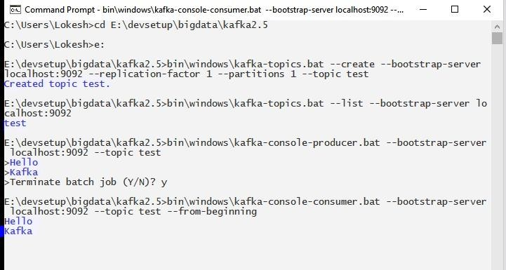

Result:
Thus the installation and configuration of Apache Kafka and perform the Producer and Consumer problem are executed successfully.

